**PATUAKHALI SCIENCE AND TECHNOLOGY UNIVERSITY**

**COURSE CODE MAT-121**

**SUBMITTED TO:**

**Dr. Muhammad Masudur Rahman**

Professor,  
[Department of Mathematics](https://pstu.ac.bd/department/department-of-mathematics)  
[Faculty of Computer Science and Engineering](https://pstu.ac.bd/faculty/faculty-of-computer-science-and-engineering)

**SUBMITTED BY:**

**Name :**

ID:

Registration No:

**Faculty of Computer Science and Engineering**

Second semester final examination

Assignment title: All chapters note

**Matrix**

- Matrix is a rectangular arrangement of numbers (real number/ complex number) in m rows and n columns is called matrix of order (or size) m by n matrix.

**Row (/column) matrix**

- A matrix in which there is only one row is called a row matrix.

**Null**

- A matrix in which every element is zero is called an null matrix.

**Equal**

- Two matrices are said to be equal if and only if they are of the same order (i.e. they have the same row and column number) and each element of one is equal to the corresponding of the other one.

**Square**

- An m x n matrix A is said to be a square matrix if m = n, i.e. number of rows is equal to the number of columns.

**Diagonal**

- A square matrix is called diagonal matrix if each of it’s non diagonal element is zero

**Scalar**

- A diagonal matrix whose diagonal elements are all equal

**Unity/ Identity**

- A square matrix where diagonal elements are unity (or one) and remaining elements are zero

Sub

**Upper (/Lower) triangle**

- A square matrix in which all the elements below the principal diagonal are zero

**Symmetric**

- A square matrix in which aij = aji i.e. (i, j)th element is the same as the (j, i)th element

**Skew symmetric**

- A square matrix in which aij = -aji i.e. (i, j)th element is the negative (j, i)th element

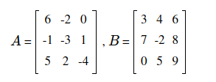

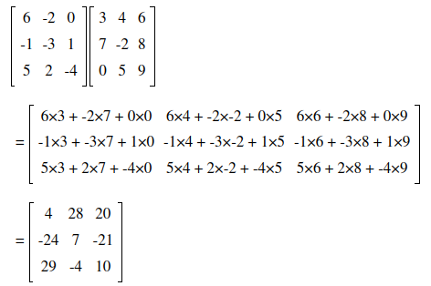

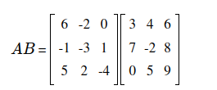

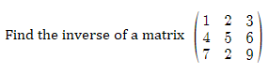

Let us find the minors of the given matrix as given below:

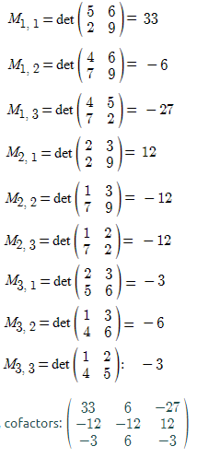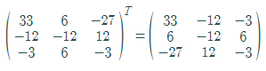

Now,

A-1 = (1/|A|) Adj A

Hence, the inverse of the given matrix is:

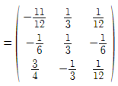

**Solve the following equations by matrix inversion**

2x+y+2z=0

2x-y+z=10

x+3y-z=5

The given equation can be written in a matrix form as AX = D, and then by obtaining A-1 and multiplying it on both 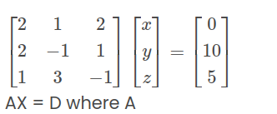sides, we can solve the given problem.

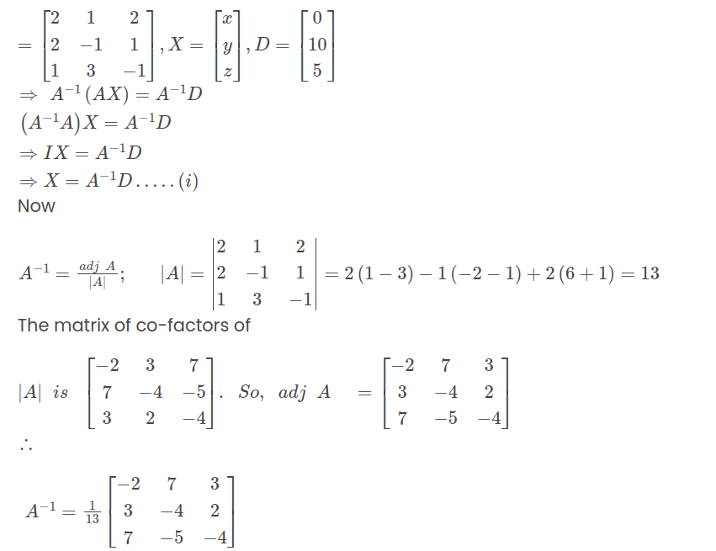

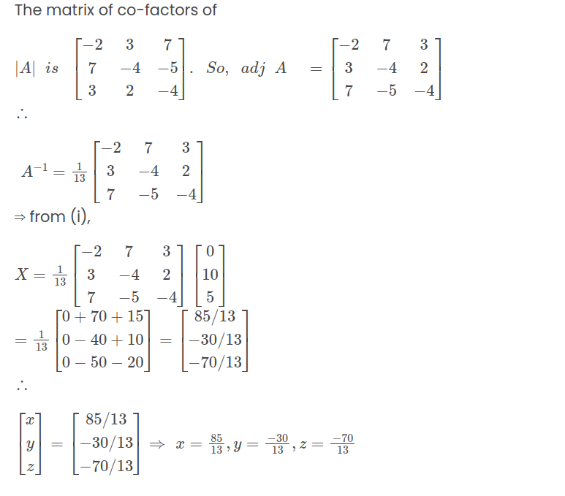

### **Rank of a Matrix**

**Example 1:** Find the rank of matrix A by using the row echelon form.

A= $\left[\begin{matrix}1 & 2 & 3 \\ 2 & 1 & 4 \\ 3 & 0 & 5\end{matrix}\right]$

**Solution:**

Given,

A = $\left[\begin{matrix}1 & 2 & 3 \\ 2 & 1 & 4 \\ 3 & 0 & 5\end{matrix}\right]$

Now, we apply elementary transformations.

R2 → R2 – 2R1

R3 → R3 – 3R1

We get

R3 → R3 – 2R2

The above matrix is in row echelon form.

Number of non-zero rows = 2

Hence, the rank of matrix A = 2.

**Example 2:** Find the rank of the given matrix.

A= $\left[\begin{matrix}1 & 2 & 3 \\ 2 & 3 & 4 \\ 3 & 5 & 7\end{matrix}\right]$

**Solution:**

Given,

A= $\left[\begin{matrix}1 & 2 & 3 \\ 2 & 3 & 4 \\ 3 & 5 & 7\end{matrix}\right]$

Now, we transform matrix A to echelon form by using elementary transformation.

R2 → R2 – 2R1

R3 → R3 – 3R1

R3 → R3 – R2

Number of non-zero rows = 2

Hence, the rank of matrix A = 2

**Eigenvalue and Eigenvector**

**Let** **A be an** **n****×****n** matrix.

1. An eigenvectorof A is a nonzero vector v in Rn such that Av=λv, for some scalar λ
2. An eigenvalueof A is a scalar λ such that the equation Av=λv has a nontrivial solution.

If Av=λv for v≠0, we say that λ is the eigenvalue for v, and that v is an eigenvector for λ.

The **characteristic equation** is the equation which is solved to find a matrix's [eigenvalues](https://mathworld.wolfram.com/Eigenvalue.html), also called the characteristic polynomial.

**Determine the characteristics roots of the matrix**

$$\left[\begin{matrix}4 & −20 & −10 \\ −2 & 10 & 4 \\ 6 & −30 & −13\end{matrix}\right]$$

**Solution:** Let, A = $\left[\begin{matrix}4 & −20 & −10 \\ −2 & 10 & 4 \\ 6 & −30 & −13\end{matrix}\right]$

The order of A is 3 X 3, so the unit matrix I = $\left[\begin{matrix}1 & 0 & 0 \\ 0 & 1 & 0 \\ 0 & 0 & 1\end{matrix}\right]$

Now we have to multiply λ with unit matrix I,

λI = $\left[\begin{matrix}λ & 0 & 0 \\ 0 & λ & 0 \\ 0 & 0 & λ\end{matrix}\right]$

$$A−λI=\left[\begin{matrix}4−λ & −\text{20} & −\text{10} \\ −2 & \text{10}−λ & 4 \\ 6 & −\text{30} & −\text{13}−λ\end{matrix}\right]$$

= (4-λ )[(10-λ )(-13-λ )+120]+ 20[-2(-13-λ )-24]-10[60-6(10-λ )]

= (4-λ)[-10+3λ +λ2]+20[2+2λ ]-10[6λ]

= 4λ2+12λ -40-λ3-3λ2+10λ +40λ +40-60λ

= λ3 + 1λ2 + 2λ

To find roots let |A-I| = 0

λ3 + 1λ2 + 2λ = 0

For solving this equation -λ from all the terms

λ3 + 1λ2 + 2λ = 0

-λ=0 (or) λ2-1λ -2=0

λ = 0, -1, 2

Therefore the characteristic roots (or) Eigen values are x = 0, -1, 2

**Determine the characteristics vector of the matrix**

$$\left[\begin{matrix}1 & 1 & 3 \\ 1 & 5 & 1 \\ 3 & 1 & 1\end{matrix}\right]$$

**Solution:** Let, A = $\left[\begin{matrix}1 & 1 & 3 \\ 1 & 5 & 1 \\ 3 & 1 & 1\end{matrix}\right]$

The order of A is 3 X 3, so the unit matrix I = $\left[\begin{matrix}1 & 0 & 0 \\ 0 & 1 & 0 \\ 0 & 0 & 1\end{matrix}\right]$

Now we have to multiply λ with unit matrix I,

λI = $\left[\begin{matrix}λ & 0 & 0 \\ 0 & λ & 0 \\ 0 & 0 & λ\end{matrix}\right]$

A – λI = $\left[\begin{matrix}1 & 1 & 3 \\ 1 & 5 & 1 \\ 3 & 1 & 1\end{matrix}\right]$- $\left[\begin{matrix}λ & 0 & 0 \\ 0 & λ & 0 \\ 0 & 0 & λ\end{matrix}\right]$

A – λI = $\left[\begin{matrix}1−λ & 1 & 3 \\ 1 & 5−λ & 1 \\ 3 & 1 & 1−λ\end{matrix}\right]$

= (1-1) [(5-λ ) (1-λ ) - 1]-1 [1(1-λ ) - 3] + 3 [1-3 (5-λ )]

= (1-λ ) [λ ²-6λ +4] -1[-2-λ ] + 3[-14+3λ ]

= - λ3 + 7 λ² - 36

To find roots let | Α-ΛΙ| = Ο

- λ3 + 7 λ² - 36 = 0

Therefore the characteristic roots are x = 3, -2, 6

Substitute λ = 3 in the matrix A-λI = $\left[\begin{matrix}−2 & 1 & 3 \\ 1 & 2 & 1 \\ 3 & 1 & −2\end{matrix}\right]$

From this matrix we are going to form three linear equations using variables x, y and z

-2x+ 1y + 3z = 0 ………………...(1)

1x + 2y + 1z = 0 ………………...(2)

3x + 1y – 2z = 0 ………………...(3)

By solving (1) and (2) we get the eigen vector

The eigen vector x = $\left[\begin{matrix}1 \\ −1 \\ 1\end{matrix}\right]$

Substitute λ = -2 in the matrix A-λI = $\left[\begin{matrix}3 & 1 & 3 \\ 1 & 7 & 1 \\ 3 & 1 & 3\end{matrix}\right]$

From this matrix we are going to form three linear equations using variables x, y and z

3x+ 1y + 3z = 0 …………………..(4)

1x + 7y + 1z = 0 ………………...(5)

3x + 1y + 3z = 0 ………………...(6)

By solving (4) and (5) we get the eigen vector

The eigen vector y = $\left[\begin{matrix}−1 \\ 0 \\ 1\end{matrix}\right]$

Substitute λ = 6 in the matrix A-λI = $\left[\begin{matrix}−5 & 1 & 3 \\ 1 & −1 & 1 \\ 3 & 1 & −5\end{matrix}\right]$

Simillarly, by solving it, we get,

The eigen vector z = $\left[\begin{matrix}1 \\ 2 \\ 1\end{matrix}\right]$

**Cayley-Hamilton Theorem**

• "A square matrix satisfies its own characteristic equation".

• Every square matrix satisfied its own characteristic equation

I.e. if A is an n x m matrix whose characteristic equation is,

Suppose the characteristic polynomial of an n × n square [matrix](https://www.cuemath.com/algebra/solve-matrices/), A, is given as   
p(λ) = λn+an−1λn−1+...+a1λ+a0

Then p(A) = An+an−1An−1+...+a1A+a0In= 0  
Thus, p(A) = 0.

**Scalar Quantity**  
A scalar quantity is defined as the physical quantity with only magnitude and no direction.

**Vector Quantity**  
A vector quantity is defined as the physical quantity that has both directions as well as magnitude.

**WORKED OUT EXAMPLES**

**Example 1**   
Find the angle between the vectors 2i + j + k -j + 2k and also find a unit vector perpendicular to the above vector [D.U.P. 1980]

Let a = 2i + j + k and b = i − j + 2k

then a.b = (2i + j + k) · (i - j + k)

= 2i i − j j + 2k · k + 0

= 2-1 + 2

= 3.

Also |a| = |2i + j + k| = √6

|b| = |i − j + 2k| = = √6

Let $∅$ be the angle between the two vectors a and b then

cos θ= $\frac{a.b}{\left|a\right|\overset{˙}{\left|b\right|}}$ = $\frac{3}{√6√6}$ = $\frac{3}{6}$ = $\frac{1}{2}$ = cos60 $°$

Second portion

Again a × b = (2i + j + k) × (i − j + 2k)

= 2i × i - 2i × j + 4i × k + j ×i-j×j

+2j×k + k × i − k × j + 2k × k

= 0 - 2k - 4j-k – 0 + 2i + j+i+0

=3i-3j-3K

Now the required unit vector e is given by

e= $\frac{a×b}{\left|a×b\right|}$ = $\frac{\left|3i−3j−3k\right|}{\sqrt{3^{2}+{\left(−3\right)}^{2}+{\left(−3\right)}^{2}}}$ = $\frac{3\left(i−j−k\right)}{3√3}$

**Example 5**

What is the unit vector perpendicular to each of the vector’s **u = i + 2j+3k** and **v=5i - j + 2k,** Calculate the sine of the angle between these vectors. D

**Solution:** u * v = (i + 2j+3k) x (5i-j+2k)

| I j k |

|1 2 3 |

|5 -1 2 |

=7i+13j-11k

:: |u* v|= =

If n be a unit vector perpendicular to the plane of u and B, then since u, v is also perpendicular to the plane of u and v, we have:

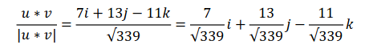Again, |u|=|i+2j+3k|=

|v|=|5i-j+2k|=

Now let 6 be the angle between the directions of u and v then u *v=|u| |v| n

Or, $sinθ$ = $\frac{u∗v}{\left|u\right|\left|v\right|n}$

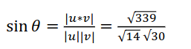Or,

$sinθ=\sqrt{\frac{339}{420}}$

**Example 7.** Prove that [c * a a * b b * c] = [a b c]2

**Proof :** [c*a a*b b*c] = (c*a) .{(c*a). (a*b). (b*c)}

= {(c*a) * (a*b)}. (b*c)

Let c*a =P then we have

(c*a) * (a*b) = P * (a*b)

= (p.b)a – (p.a)b

Now putting the value of **P** in the above equation, we have

(c*a) * (a*b) = (c*a.b)a – (c*a.a)b

=[cab]a – 0 *since* **c * a.a = 0**

= [cab]a.

[c*a a*b b*c] = {(c*a) * (a*b) * (b*c)}

= [cab]a . (b*c)

=[cab] . [abc] *since* **[cab]=[abc]**

**=** [abc].[abc] = [abc]2

*Hence* **[c*a a*b b*c]= [abc]2.**